**Viral Advertising**

https://d3keuzeb2crhkn.cloudfront.net/s3_pub/hr-avatars/a97ec6c5-b55c-4fa3-80e7-5bcba1afdcff/150x150.png**by [Shafaet](https://www.hackerrank.com/Shafaet)**

* [**Problem**](https://www.hackerrank.com/challenges/strange-advertising)
* [**Submissions**](https://www.hackerrank.com/challenges/strange-advertising/submissions)
* [**Leaderboard**](https://www.hackerrank.com/challenges/strange-advertising/leaderboard)
* [**Discussions**](https://www.hackerrank.com/challenges/strange-advertising/forum)
* [**Editorial**](https://www.hackerrank.com/challenges/strange-advertising/editorial)

HackerLand Enterprise is adopting a new viral advertising strategy. When they launch a new product, they advertise it to exactly  people on social media.

On the first day, half of those  people (i.e., ) like the advertisement and each person shares it with  of their friends; the remaining people (i.e., ) delete the advertisement because it doesn't interest them. So, at the beginning of the second day,  people receive the advertisement.

On the second day, half of the  people who received the advertisement share it with  new friends. So, at the beginning of the third day,  people receive the advertisement. The diagram below depicts the advertisement's virality over the first three days (green denotes a person that likes the advertisement and red denotes a person that disliked and deleted it):

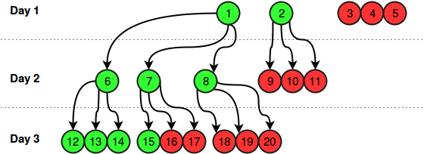

Assume that at the beginning of the  day,  people received the advertisement, people like and share it with  new friends, and  people dislike and delete it. At the beginning of the  day,  people receive the advertisement.

Given an integer, , find and print the total number of people who *liked HackerLand Enterprise's advertisement* during the first  days. It is guaranteed that no two people have any friends in common and, after a person shares the advertisement with a friend, the friend always sees it the next day.

**Input Format**

A single integer, , denoting a number of days.

**Constraints**

**Output Format**

Print the number of people who liked the advertisement during the first  days.

**Sample Input**

3

**Sample Output**

9

**Explanation**

This example is depicted by the diagram at the top of the challenge.  people liked the advertisement on the first day,  people liked the advertisement on the second day and people liked the advertisement on the third day, so the answer is .

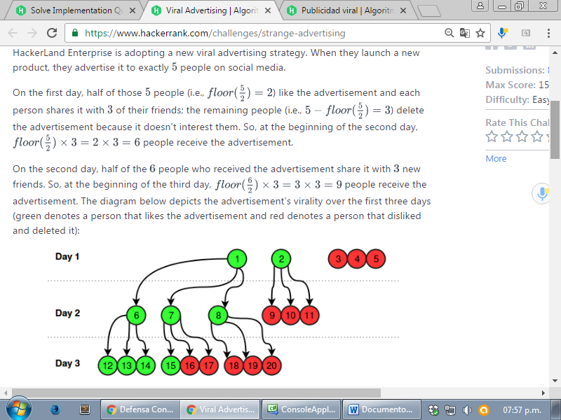

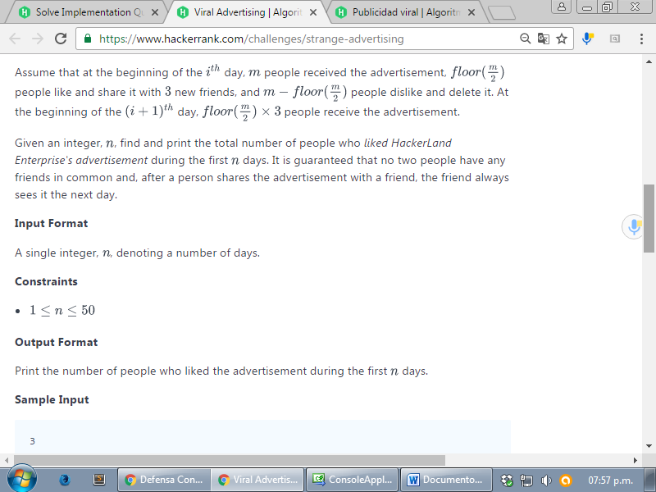

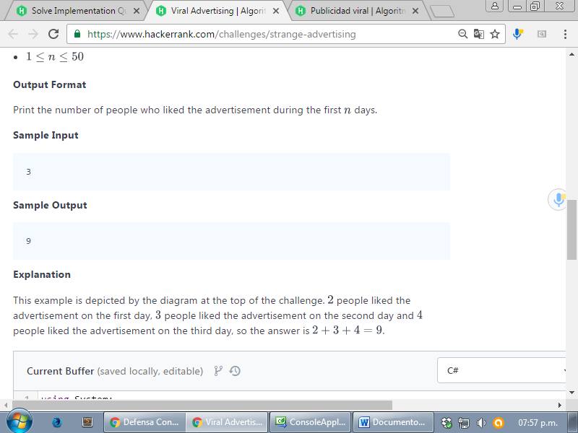

<https://www.hackerrank.com/challenges/strange-advertising>

using System;

using System.Collections.Generic;

using System.Linq;

using System.Text;

namespace ConsoleApplication1

{

class Program

{

static void Main(string[] args)

{

int n = int.Parse(Console.ReadLine());

int people = 5;

int sum = 0;

for (int i = 0; i < n; i++)

{

//int res = people - (int)Math.Floor((people / (double)2));

int res = (int)Math.Floor((people / (double)2));

// Console.WriteLine(res);

sum += res;

people = res * 3;

}

Console.WriteLine( sum);

Console.ReadLine();

}

}

}